

This file was brought to you by ARS 4.0

We have many more great shares just like this one.

So please accept this invitation to our humble home.

http://sasecrets.com/

Click in the manhole for the Login/Registrationp
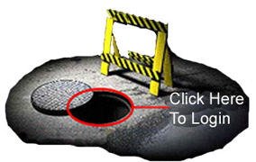a
ge.
After entering please post an introduction.

We Hope To See You There
The ARS 4.0 Staff

